**Matthew Schramm Assignment 5 report**

1. **What my OO design is:**

My OO design consists of 6 classes all interacting with each other in a sequential way to create a functioning graph that we will be using to perform Dijkstra’s method on a generated dataset. The edge and vertex class are the base classes of the design with them creating the various vertex and edge objects that will be inside the graph. Following these 2 classes is the path class which uses both the vertex and edge classes to create and output a path that is taken through the graph created and then finally the graph class which uses the Vertex, edge and path class functions and objects to create a working Graph that can perform, Dijkstra’s algorithm, print the path that is taken and overall allow for data to be abstracted for use in calculations such as the one we are doing in this assignment lastly we have the GraphException class which allows for various exceptions to be output and fixed that may occur in the graph class. Then we have the GraphExperiment class that contains the main method of the design, which I created to generate the datasets that will be used in the various calculations, the class once generated the dataset will add to the various nodes containing vertices and edges to a new graph object where Dijkstra’s algorithm is performed allowing for the complexity to be calculated. The entirety of the problem that we are addressing in this OO design is solved through the running of the GraphExperiment class which through encapsulation uses all the classes mentioned previously.

1. **What the goal of the experiment is and how you executed the experiment. Report on any experiment design decisions you made.**

The goal of the experiment is to see how well the Dijkstra algorithm conform to our expectation in terms of its performance or in other words we have this theoretical bounds of performance and we want to see through generation of datasets and running of the algorithm does this fit this theoretical bound of performance. We do this through the creation of a class that will generate datasets based on a certain vertices value and edges value which will then be inputted into the graph class where a graph will be created. Once we have a graph object containing the nodes of the generated dataset we perform Dijkstra’s algorithm on it where we have instrumentation that counts the number of comparisons that are performed throughout the algorithm increment a vertices count variable. This data is then stored and output to a CSV file where graphs are created showing the bounds of the complexity E log V in action and allowing us to deduct and prove that the algorithm does fit this theoretical bound of performance.

1. **What the goal of the experiment is and how you executed the experiment. Report on any experiment design decisions you made.**

* Results of very small values of edges with instrumentation that counts the processing of vertices, edges and the priority.

Table 1: To show the values of the data that is being used in the experiment

Graph 1: To show the relationship between Operations and the Vertices (V)

Graph 2: To show the relationship between Operations and the Edges (E)

Graph 3: To show the relationship between Operations (blue) and E log V (orange)

* Results of very small values of edges with instrumentation that only increments every time a comparison is performed

Table 1: To show the values of the data that is being used in the experiment



Graph 1: To show the relationship between Operations and the Vertices (V)

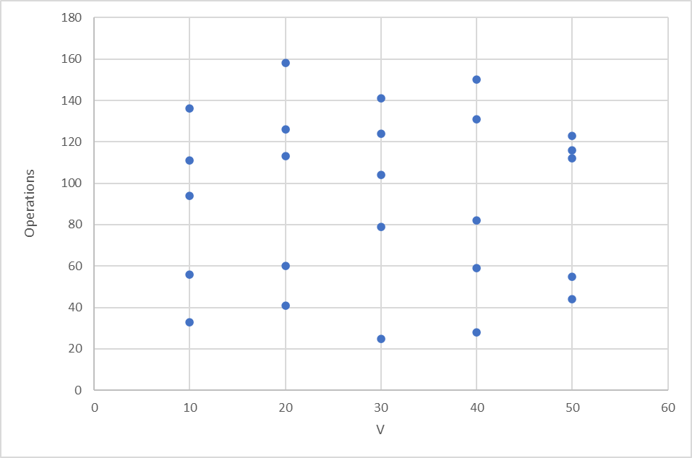

Graph 2: To show the relationship between Operations and the Edges (E)

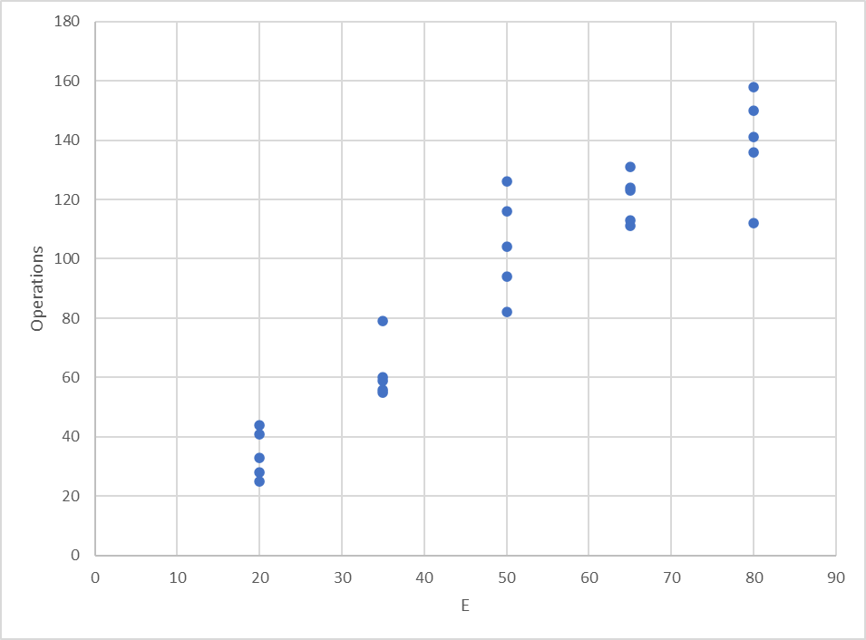

Graph 3 & 4: To show the relationship between Operations (blue) and E log V (orange)

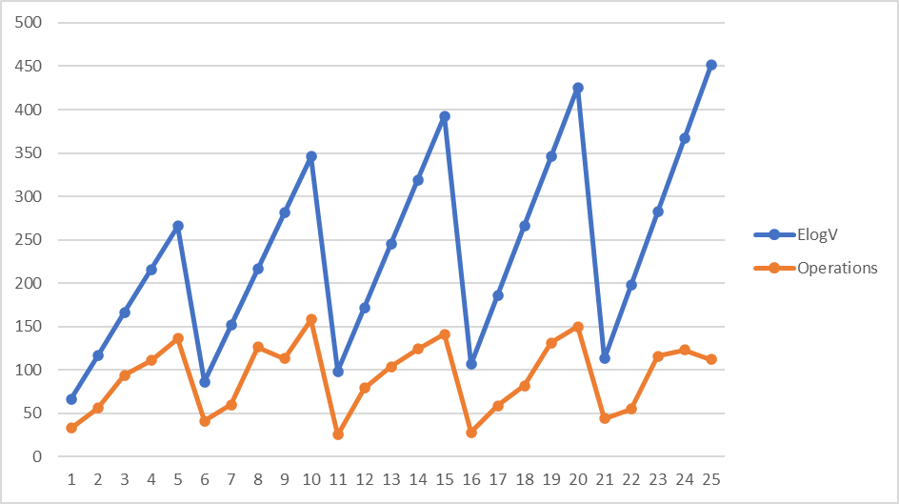

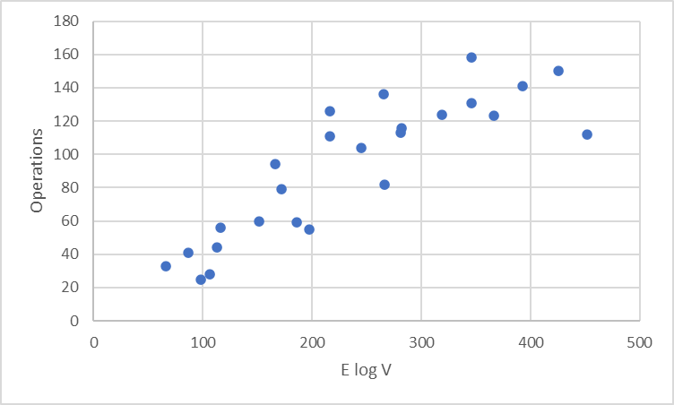

* Results of very large values of edges with instrumentation that only increments every time a comparison is performed

Table 1: To show the values of the data that is being used in the experiment

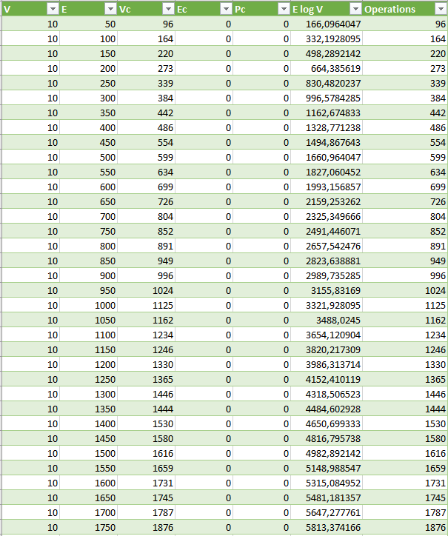

Values do continue but too many to fit in document

Graph 1: To show the relationship between Operations and the Vertices (V)

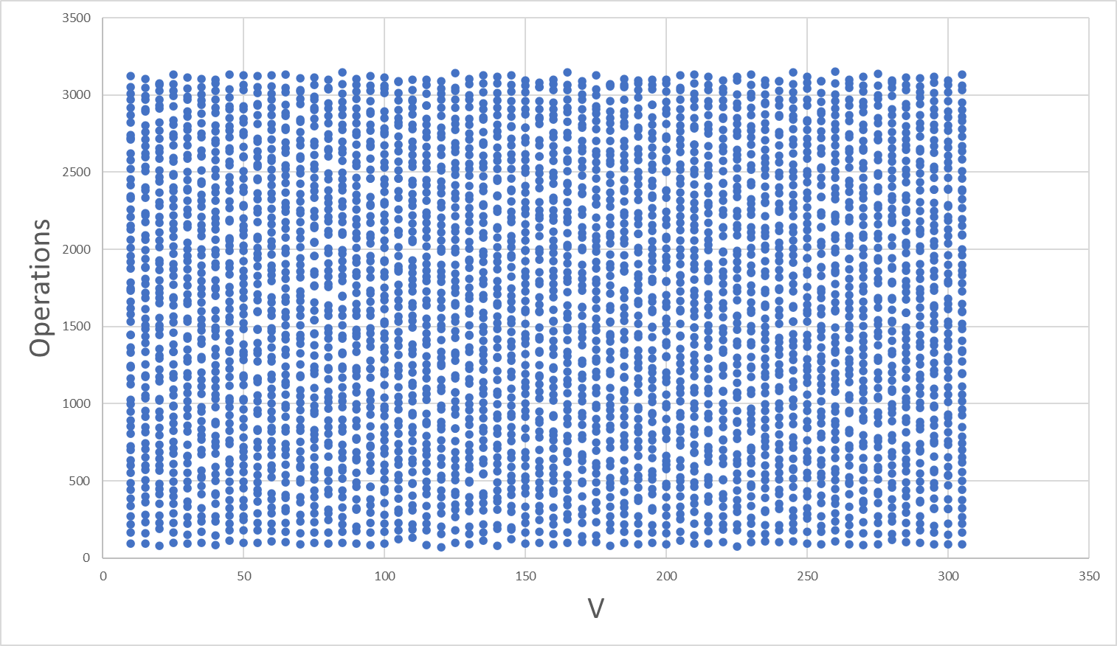

Graph 2: To show the relationship between Operations and the Edges (E)

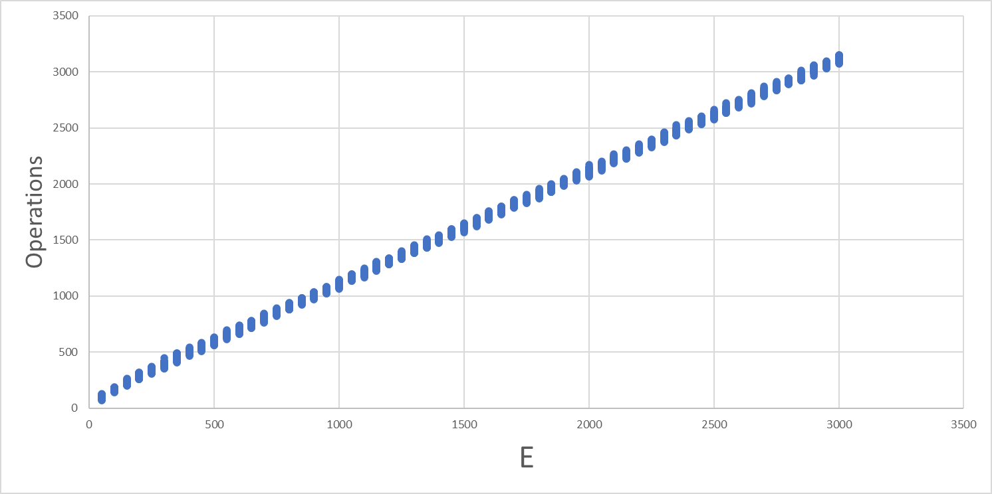

Graph 3 & 4: To show the relationship between Operations and E log V Values

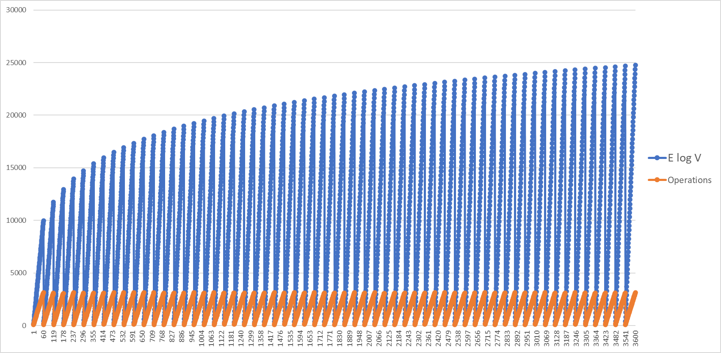

1. **Discuss what the results mean. Compare your results to the theoretical bounds.**

The results that I have concluded and produced using my program depict that the theoretical bounds do hold to be true however as there is a lot of variability throughout the conducting of these graphs and the experiments the lines produced in the final graph 4 has outliers such as the first line. However the theoretical bound of E log V does hold true as seen in Graph 3 on page 7 there is a bound that limits the operations to pass through showing true to our experiments and the goal of the experiment that the algorithm does fit the performance of the theoretical bound.

1. **Summary statistics from your use of git to demonstrate usage**

0: commit b201f72528eab606d90cf2b598ed4d5365a3ba9e

1: Author: Matthew Schramm <mattschramm1235@gmail.com>

2: Date: Fri May 5 12:32:29 2023 +0200

3:

4: Final and complete version ready to hand in

5:

6: commit cea04109e5eb070bf613ffa5504f6715a0e980f3

7: Author: Matthew Schramm <mattschramm1235@gmail.com>

8: Date: Thu May 4 16:04:37 2023 +0200

9:

...

10: code working and files generated